Computer Accessibility for Individuals with Disabilities

Created by Jamie O’Quinn
Mississippi Digital Humanities Hub, USM

Email: jamie.oquinn@usm.edu

Overview

Computer accessibility for individuals with disabilities is a broad term, encompassing not only types of modifications, software, or hardware, but also addressing the specific needs of the user on an individual basis. While a specific diagnosis of a disability might help point in a general direction to be considered as a starting point, it is important to remember that each person should be evaluated on an individual basis by a qualified professional to determine their own specific needs.

Because the terms and concepts of both accommodations and disabilities are so broad, this guide includes some resources that are larger in scope and then narrowed down to more specific fields. It is noted that while the purpose of this resource guide might be geared toward accessibility for individuals with disabilities, many of the accommodations can be adapted to create a better experience for all users. The resources provided are for informational purposes only and are not an endorsement of any particular product or company.

Standards and resources

WCAG (Web Content Accessibility) - The guidelines are the internationally recognized standard for making web content accessible. They are based on four core principles: perceivable, operable, understandable, and robust. https://www.w3.org/WAI/fundamentals/

W3C Web Accessibility Initiative (WAI) – Part of the WCAG, the World Wide Web Consortium develops and maintains the WCAG guidelines and emphasizes strategies, standards, and supporting resources to make the Web accessible to people with disabilities. A few topics include Accessibility Fundamentals, Tools and Techniques, and Digital Accessibility Courses. It suggests that those with cognitive, physical, and visual disabilities might benefit from using the keyboard only. Those with cognitive, physical, and visual disability might benefit from utilizing the touchscreen. Those with hand tremor or limited dexterity may benefit from using specialized software for their mouse and keyboard. Those in need of hands-free interactions might benefit from speech recognition or a virtual mouse.
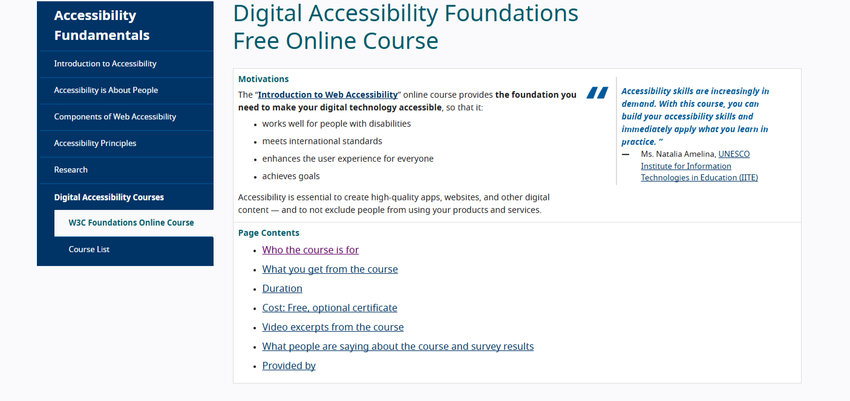

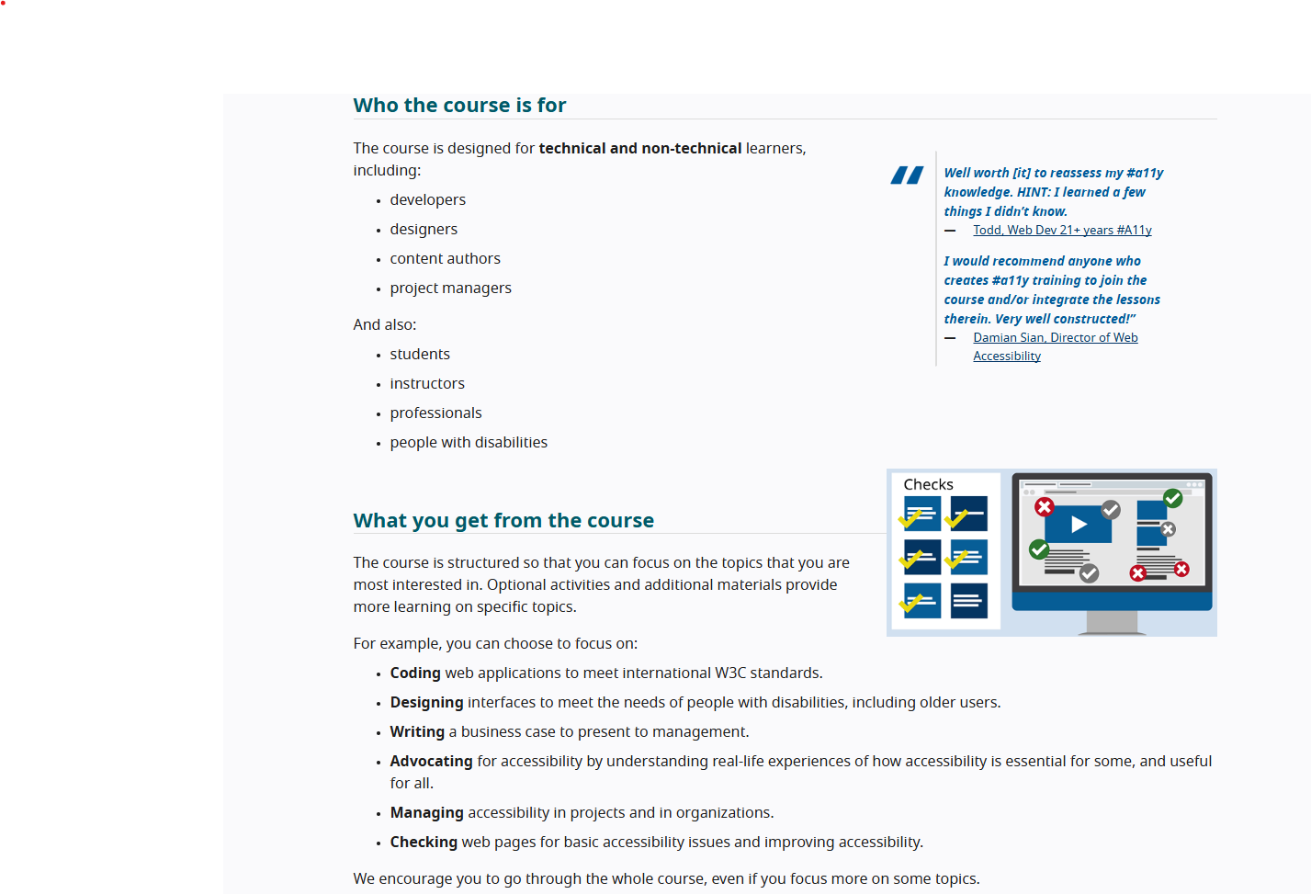

Americans with Disabilities Act - Provides guidance on web accessibility and the ADA’s requirements. https://www.ada.gov/resources/web-guidance/

Job Accommodation Network (JAN) - Job Accommodation Network for employment information. https://askjan.org/

Helen Keller Services – Helen Keller National Center for DeafBlind and Helen Keller Services for the Blind. Their mission is to enable individuals who are blind, DeafBlind, have low vision, or have combined hearing and vision loss to live, work, and thrive in their community of choice. https://www.helenkeller.org/

Assistive Technology Industry Association (ATIA) - A global leader in assistive technology education and research. https://www.atia.org/

Bookshare - A large online library of accessible books for people with reading-related disabilities.
https://www.bookshare.org/

Project Gutenberg - Provides a vast collection of free eBooks, many of which are accessible. https://www.gutenberg.org/

Tar Heel Reader - Offers a collection of free, easy-to-read, accessible books on many topics. Students can create their own books, and teachers can create customized books for students. https://monarchreader.com/

NVDA - NVDA screen reader can be downloaded free of charge. https://www.nvaccess.org/download/

EveryoneOn - Helps connect people with affordable internet services and offers digital skills training. https://www.everyoneon.org/

ReadSpeaker - There is a cost for these products. https://www.readspeaker.com/. There is an interesting blog entitled 5 Assistive Technology Tools for Students with Dyslexia by Amy Foxwell, which explains text-to-speech web reading, highlighting of text while the TTS (text to speech) engine reads it out loud, speech recognition software, writing assistance software, and text to speech. https://www.readspeaker.com/blog/assistive-technology-for-dyslexia/

WhoCanUse – This browser-based tool can be used for evaluating color and text contrasts for people with a variety of visual impairments. https://www.whocanuse.com/

Coolors - This color palette generator includes checks for contrast and color blindness. It’s also a tool for creating brand colors. https://coolors.co/

Photosensitive Epilepsy Analysis Tool (PEAT) - This is a free, downloadable software that identifies the seizure risks of video and animations. https://www.accessibility.com/glossary/peat-photosensitive-epilepsy-analysis-tool
Web Accessibility Evaluation Tool (WAVE) - WAVE is a way for website creators to evaluate their content and make it more accessible to people with disabilities. You can either enter in your website and review its accessibility, or there is an option to install a browser extension to regularly evaluate web content. https://wave.webaim.org/
The Color Blindness Simulator (COBLIS) - This is a free tool to evaluate the color blindness accessibility of still images. https://www.color-blindness.com/coblis-color-blindness-simulator/

Built-in Browser and Operating System Tools

Built-in tools for individuals with disabilities include screen readers like VoiceOver (Apple) and Narrator (Windows), speech recognition for dictation and control, and display adjustments such as high contrast and color filters. Operating systems and browsers also offer magnifiers or zoom functions, and keyboard navigation options that allow users to operate a computer without a mouse.

For those with visual disabilities
Screen readers - Convert on-screen text into speech (e.g., VoiceOver on macOS/iOS, Narrator on Windows, TalkBack on Android, ChromeVox on ChromeOS). VoiceOver: Apple-built screen reader that allows those who are blind or have low-vision to navigate and operate Apple devices through spoken descriptions and keyboard commands. https://support.apple.com/guide/voiceover/welcome/mac. JAWS (Job Access with Speech) which is a commercial screen reader for Windows.
Magnifiers/Zoom - Increase the size of on-screen content for low vision users.
High Contrast/Display Adjustments - Toggle high contrast modes, dark mode, or apply color filters to improve readability and reduce glare.
Select-to-Speak (ChromeOS) - Reads specific text that the user highlights, with visual highlighting to track words as they are spoken.
For those with motor disabilities
Speech Recognition - Allows users to dictate text and control the computer using voice commands.
Keyboard Navigation - Enables full control of the computer using the keyboard, often by using the Tab, Shift+Tab, and arrow keys.
On-screen keyboards - Provide a visual keyboard that can be operated with a mouse or other pointing device.

For those with cognitive and learning disabilities
Text-to-Speech - Customizable options for speech rate, pitch, and volume, which can help with reading comprehension.
Focus and Highlighting - Tools that can highlight the text being read to aid in focus.
Dictation - Can be helpful for individuals who have difficulty with typing.

For those with hearing disabilities
Live Captions - Can be enabled in video calls and other applications to provide a text-based representation of spoken content.
Visual Alerts - Some operating systems provide visual alerts in addition to auditory ones for incoming notifications.

